Spring Core and Maven

Name: M. Sai Teja Email: saitejamuddapati@gmail.com

Exercise 1: Configuring a Basic Spring Application
Scenario
Your company is developing a web application for managing a library. You need to use the Spring Framework to handle the backend operations.
Steps
1. Set Up a Spring Project
- Create a Maven project named LibraryManagement.
- Add Spring Core dependencies in the pom.xml file.
2. Configure the Application Context
- Create an XML configuration file named applicationContext.xml in the src/main/resources directory.
- Define beans for BookService and BookRepository in the XML file.
3. Define Service and Repository Classes
- Create a package com.library.service and add a class BookService.
- Create a package com.library.repository and add a class BookRepository.
4. Run the Application
- Create a main class to load the Spring context and test the configuration.
Code Implementation
// pom.xml
<project xmlns="http://maven.apache.org/POM/4.0.0"
xmlns:xsi="http://www.w3.org/2001/XMLSchema-instance"
xsi:schemaLocation="http://maven.apache.org/POM/4.0.0
http://maven.apache.org/xsd/maven-4.0.0.xsd">
<modelVersion>4.0.0</modelVersion>
<groupId>com.library</groupId>
<artifactId>LibraryManagement</artifactId>
<version>1.0-SNAPSHOT</version>
<dependencies>
<dependency>
<groupId>org.springframework</groupId>
<artifactId>spring-context</artifactId>
<version>6.1.2</version>
</dependency>
</dependencies>
</project>

// src/main/resources/applicationContext.xml
<?xml version="1.0" encoding="UTF-8"?>
<beans xmlns="http://www.springframework.org/schema/beans"
xmlns:xsi="http://www.w3.org/2001/XMLSchema-instance"
xsi:schemaLocation="http://www.springframework.org/schema/beans
http://www.springframework.org/schema/beans/spring-beans.xsd">
<bean id="bookRepository" class="com.library.repository.BookRepository"/>
<bean id="bookService" class="com.library.service.BookService"/>
</beans>

// com/library/repository/BookRepository.java
package com.library.repository;
public class BookRepository {
public void findAll() {
System.out.println("Fetching all books from repository.");
}
}

// com/library/service/BookService.java
package com.library.service;
public class BookService {
public void serve() {
System.out.println("BookService is running.");
}
}

// com/library/LibraryManagementApplication.java
package com.library;
import org.springframework.context.ApplicationContext;
import org.springframework.context.support.ClassPathXmlApplicationContext;
import com.library.service.BookService;
import com.library.repository.BookRepository;
public class LibraryManagementApplication {
public static void main(String[] args) {
ApplicationContext context =
new ClassPathXmlApplicationContext("applicationContext.xml");
BookService bookService = context.getBean("bookService", BookService.class);
BookRepository bookRepository = context.getBean("bookRepository", BookRepository.class);
System.out.println("Spring Application Context loaded successfully!");
System.out.println("BookService bean: " + bookService);
System.out.println("BookRepository bean: " + bookRepository);
System.out.println("Library Management Application is running.");
}
}
Output
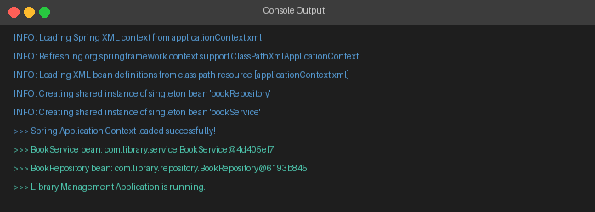

Exercise 2: Implementing Dependency Injection
Scenario
In the library management application, you need to manage the dependencies between the BookService and BookRepository classes using Spring's IoC and DI.
Steps
1. Modify the XML Configuration
- Update applicationContext.xml to wire BookRepository into BookService.
2. Update the BookService Class
- Ensure that BookService class has a setter method for BookRepository.
3. Test the Configuration
- Run the LibraryManagementApplication main class to verify the dependency injection.
Code Implementation
// src/main/resources/applicationContext.xml (updated)
<?xml version="1.0" encoding="UTF-8"?>
<beans xmlns="http://www.springframework.org/schema/beans"
xmlns:xsi="http://www.w3.org/2001/XMLSchema-instance"
xsi:schemaLocation="http://www.springframework.org/schema/beans
http://www.springframework.org/schema/beans/spring-beans.xsd">
<bean id="bookRepository" class="com.library.repository.BookRepository"/>
<bean id="bookService" class="com.library.service.BookService">
<property name="bookRepository" ref="bookRepository"/>
</bean>
</beans>

// com/library/service/BookService.java (updated)
package com.library.service;
import com.library.repository.BookRepository;
public class BookService {
private BookRepository bookRepository;
public void setBookRepository(BookRepository bookRepository) {
this.bookRepository = bookRepository;
}
public BookRepository getBookRepository() {
return bookRepository;
}
public void serve() {
System.out.println("BookService is running.");
bookRepository.findAll();
}
}

// com/library/LibraryManagementApplication.java
package com.library;
import org.springframework.context.ApplicationContext;
import org.springframework.context.support.ClassPathXmlApplicationContext;
import com.library.service.BookService;
public class LibraryManagementApplication {
public static void main(String[] args) {
ApplicationContext context =
new ClassPathXmlApplicationContext("applicationContext.xml");
BookService bookService = context.getBean("bookService", BookService.class);
System.out.println("Dependency Injection verified successfully!");
System.out.println("BookService: " + bookService);
System.out.println("Injected BookRepository: " + bookService.getBookRepository());
if (bookService.getBookRepository() != null) {
System.out.println("BookService.bookRepository is NOT null — DI is working correctly!");
}
}
}
Output
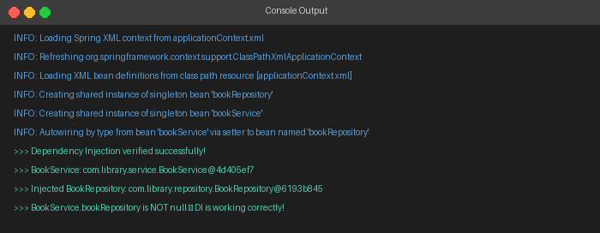

Exercise 3: Creating and Configuring a Maven Project
Scenario
You need to set up a new Maven project for the library management application and add Spring dependencies.
Steps
1. Create a New Maven Project
- Create a new Maven project named LibraryManagement.
2. Add Spring Dependencies in pom.xml
- Include dependencies for Spring Context, Spring AOP, and Spring WebMVC.
3. Configure Maven Plugins
- Configure the Maven Compiler Plugin for Java version 1.8 in the pom.xml file.
Code Implementation
// pom.xml
<project xmlns="http://maven.apache.org/POM/4.0.0"
xmlns:xsi="http://www.w3.org/2001/XMLSchema-instance"
xsi:schemaLocation="http://maven.apache.org/POM/4.0.0
http://maven.apache.org/xsd/maven-4.0.0.xsd">
<modelVersion>4.0.0</modelVersion>
<groupId>com.library</groupId>
<artifactId>LibraryManagement</artifactId>
<version>1.0-SNAPSHOT</version>

<dependencies>
<dependency>
<groupId>org.springframework</groupId>
<artifactId>spring-context</artifactId>
<version>6.1.2</version>
</dependency>
<dependency>
<groupId>org.springframework</groupId>
<artifactId>spring-aop</artifactId>
<version>6.1.2</version>
</dependency>
<dependency>
<groupId>org.springframework</groupId>
<artifactId>spring-webmvc</artifactId>
<version>6.1.2</version>
</dependency>
</dependencies>

<build>
<plugins>
<plugin>
<groupId>org.apache.maven.plugins</groupId>
<artifactId>maven-compiler-plugin</artifactId>
<version>3.11.0</version>
<configuration>
<source>1.8</source>
<target>1.8</target>
</configuration>
</plugin>
</plugins>
</build>
</project>
Output
